AWS EKS:

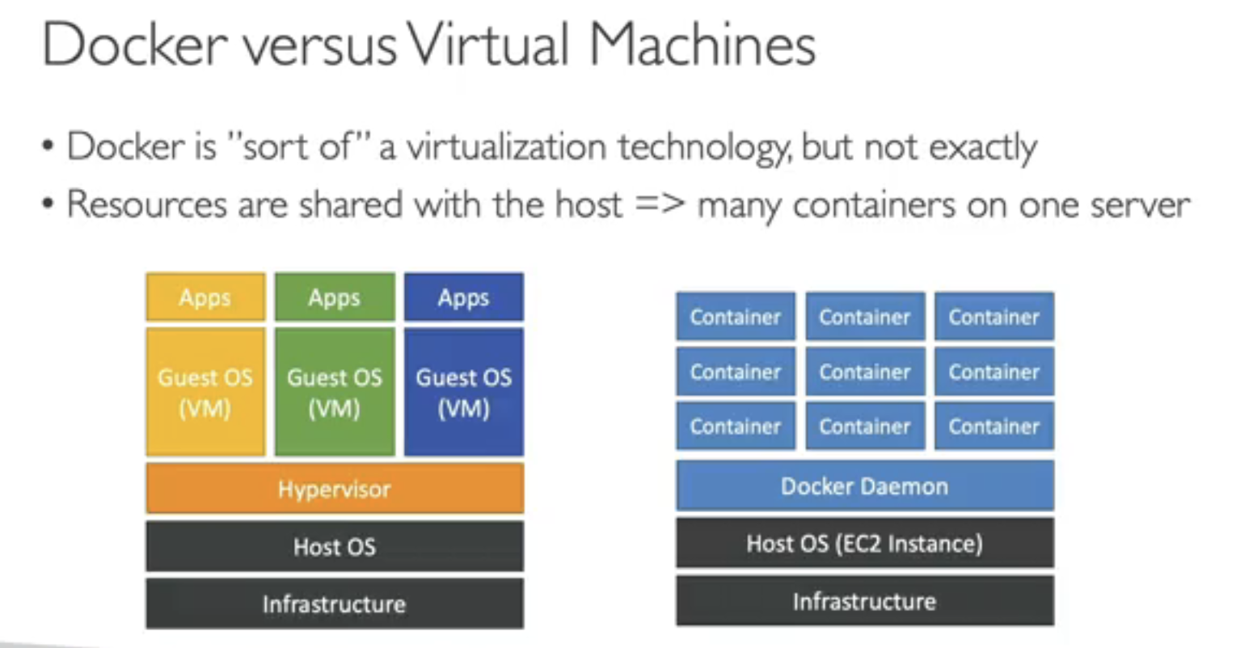

ECS (Elastic Container Service):

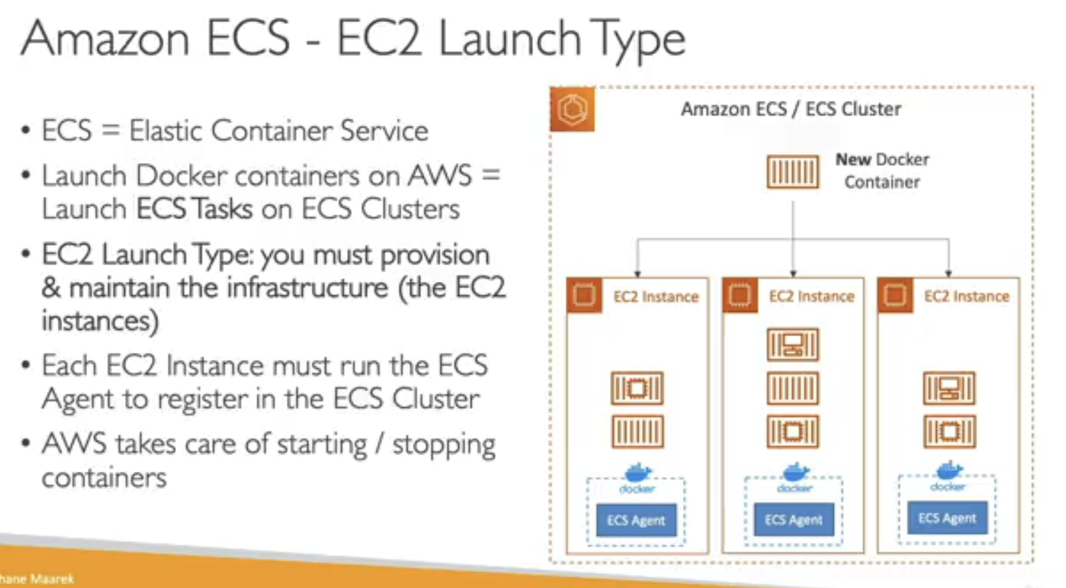

ECR:

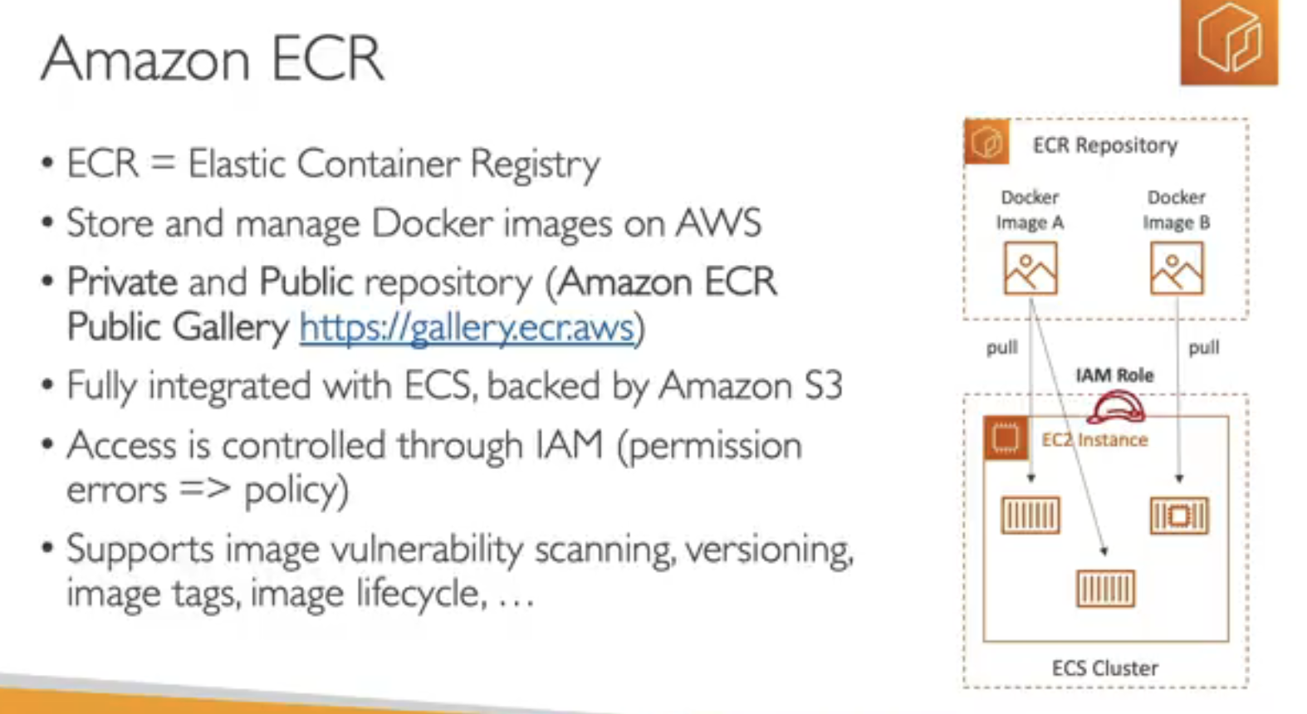

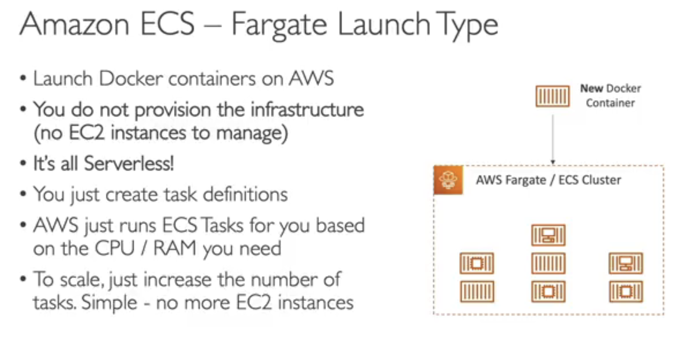

The **EC2 launch type** and **Fargate launch type** in Amazon ECS (Elastic Container Service) determine how containers are deployed and managed, particularly concerning the infrastructure used. Here’s a comparison of the two:

**1. Infrastructure Management**

* **EC2 Launch Type**:
  + Requires managing and provisioning Amazon EC2 instances as the underlying compute for container instances.
  + You control the EC2 instance types, scaling policies, and have full flexibility in configuring the instances.
  + Ideal if you need granular control over the EC2 instances, such as selecting specific instance types, configuring underlying OS, or if you need to run agents/sidecar containers directly on instances.
* **Fargate Launch Type**:
  + Completely serverless, so AWS handles the infrastructure, including scaling, provisioning, and managing the compute resources.
  + You only define the CPU and memory requirements per task, and AWS provisions resources based on these settings.
  + Ideal for running containers without managing any EC2 infrastructure.

**2. Scalability**

* **EC2 Launch Type**:
  + You’re responsible for configuring autoscaling for the EC2 instances.
  + Scaling up or down can require provisioning or terminating instances manually or via scaling policies.
* **Fargate Launch Type**:
  + Scaling is handled automatically by Fargate based on the number of tasks. Fargate spins up resources as needed and scales down when tasks end.

**3. Pricing and Cost Efficiency**

* **EC2 Launch Type**:
  + You pay for the provisioned EC2 instances, regardless of task utilization.
  + More cost-effective if you have consistently high usage, especially with Reserved or Spot Instances.
* **Fargate Launch Type**:
  + You’re billed per-second based on the CPU and memory used by each task.
  + More cost-efficient for workloads with fluctuating usage, as you’re only billed for the exact resources consumed per task.

**4. Use Cases**

* **EC2 Launch Type**:
  + Suitable for applications requiring control over the instance’s lifecycle, OS, and network configuration.
  + Good for complex applications that might need customization at the instance level.
* **Fargate Launch Type**:
  + Best for running microservices or simpler applications where you want a managed, serverless experience.
  + Great for applications with variable or unpredictable loads, as Fargate automatically manages resource provisioning.

In summary, the **EC2 launch type** is ideal if you need granular control and are okay with managing the instances, while **Fargate** is best for a fully managed, serverless experience where AWS handles all infrastructure details.

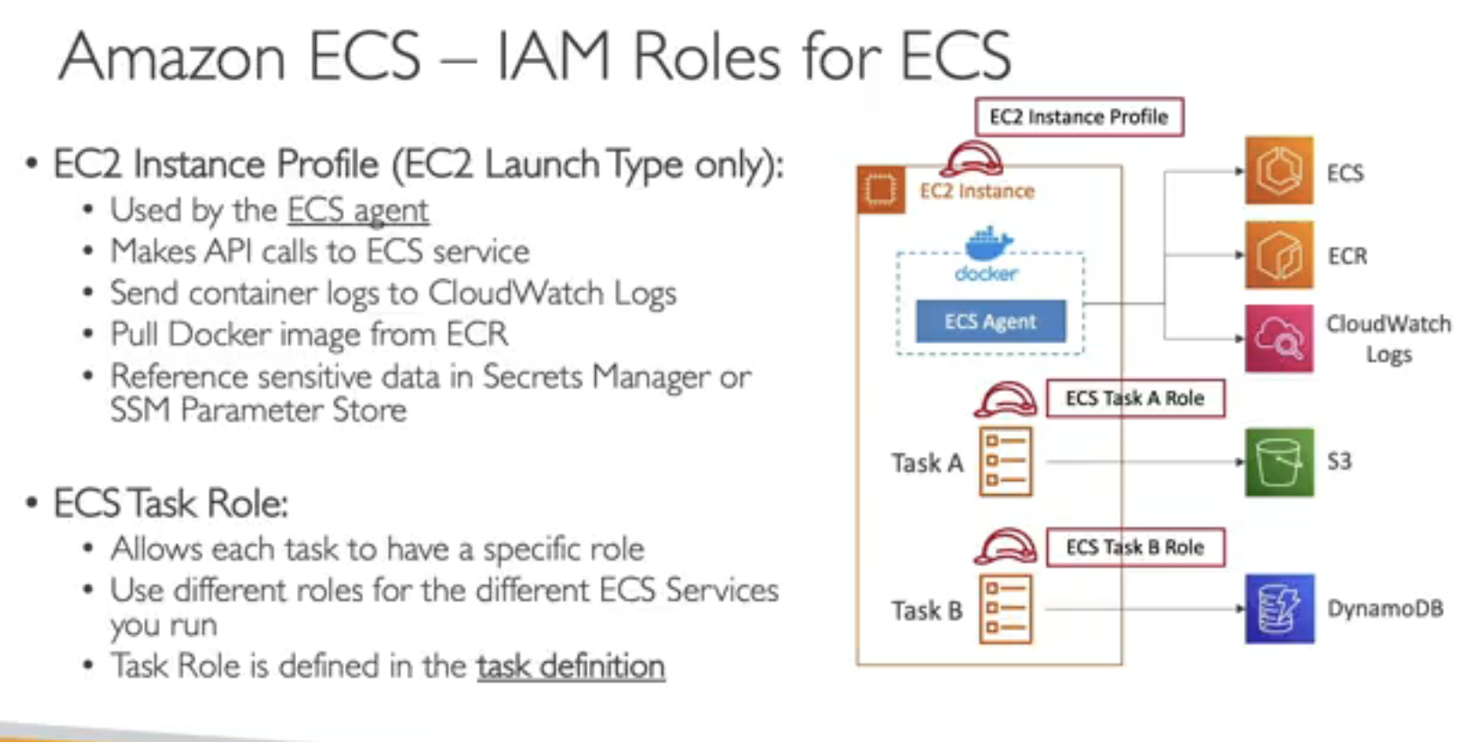

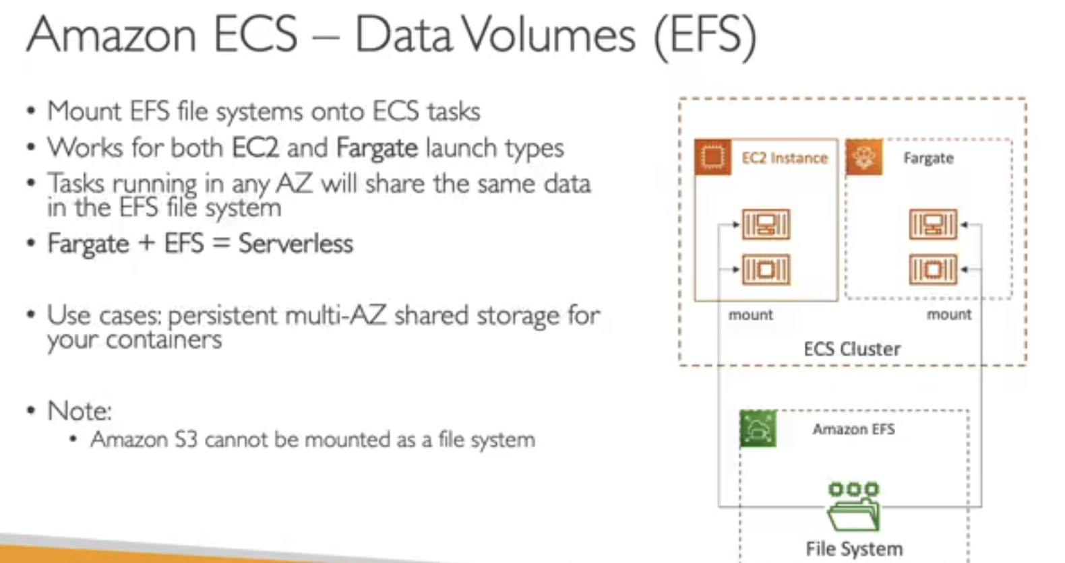

EKS:

